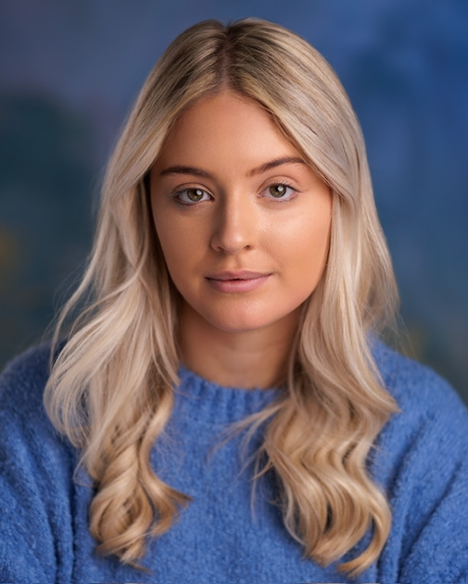
Madison Gardiner

Representation: Murdoch Artists
Spotlight: 0930-5616-2962
Email: madisongardiner@icloud.com
Phone: 07956311466

Age: 20
Height: 5ft 4”
Hair: Blonde
Eye: Hazel/Green
Nationality: Scottish
Based in: Edinburgh

Previous work
Play | Character | Company | Director
Greece | Marty | Broughton High School | Lori Kennedy
Mother Goose | Ensemble | New College Lanarkshire | Amanda Beveridge
Legally Blonde | Margot | New college Lanarkshire | Francis Lyons

Accents:
Scottish*, RP, General American.

Skills:
Mezzo soprano Ballet
Beginner majorettes Jazz
Guitar (acoustic and electric) Contemporary
Can swim

